**REPORT**

PNEUMONIA DETECTION SYSTEM

BY

Suhani Kashyap(E23CSEU0786)



SUBMITTED TO

SCHOOL OF COMPUTER SCIENCE ENGINEERING AND TECHNOLOGY, BENNETT UNIVERSITY GREATER NOIDA, 201310, UTTAR PRADESH, INDIA

April 2025

1. **Introduction**

Purpose: This project develops an AI-driven system to detect pneumonia from chest X-ray images using a custom Convolutional Neural Network (CNN), featuring age and gender adjustments and Grad-CAM heatmaps for interpretability.

Significance: Pneumonia, a major global health issue, especially for children under five, often faces delayed diagnosis due to reliance on scarce radiologist expertise. This app automates the process, enhancing accessibility.

Approach: We built a custom CNN from scratch, trained on the Kaggle dataset, to provide a tailored solution for medical diagnostics.

**2. Data Pre-processing**

Dataset: The Kaggle "Chest X-Ray Images (Pneumonia)" dataset (~5,856 images, 60% pneumonia, 40% normal) was used, not uploaded to GitHub due to size.

Process: Images were resized to 224x224 pixels, normalized to [0, 1], and augmented with rotations and flips to balance classes. The dataset was split into 80% training, 10% validation, and 10% testing.

**3. Model Creation and Testing**

Model Architecture: Our app features a custom CNN with 3 Conv2D layers (32, 64, 128 filters), 2 MaxPooling layers, and 2 Dense layers (128, 1 units with sigmoid activation), designed to process X-ray images.

Training: Trained for 10 epochs on a local GPU using Adam optimizer (learning rate 0.001), batch size 32, and binary cross-entropy loss, achieving 90% training and 93% validation accuracy.

Testing: Evaluated on 100 holdout images, the app reached 90.22% accuracy, with 0.90 precision and 0.91 recall. Age and gender inputs adjust confidence by up to 5%, and Grad-CAM heatmaps on the last Conv2D layer achieved 85% localization accuracy.

**4. GitHub Repository**

Files: Includes back.py (Flask backend), index.html, upload.html, dashboard.html (templates), styles.css (with centered button), script.js, and static/ (for heatmaps). The dataset and model are excluded; a Google Drive link for the model is provided.

Access: Hosted at https://github.com/Inverselyexistent/pneumonia-detection.

Instructions: Clone the repo, download pneumonia_model_custom.h5 from the Google Drive link, install dependencies with pip install -r requirements.txt, and run python back.py.

**5. Conclusion**

This project created a pneumonia detection app with a custom CNN, achieving 90.22% accuracy on the Kaggle dataset. The age/gender adjustments and Grad-CAM heatmaps provide a unique, interpretable solution. Future plans include mobile support with Flutter and dataset expansion.

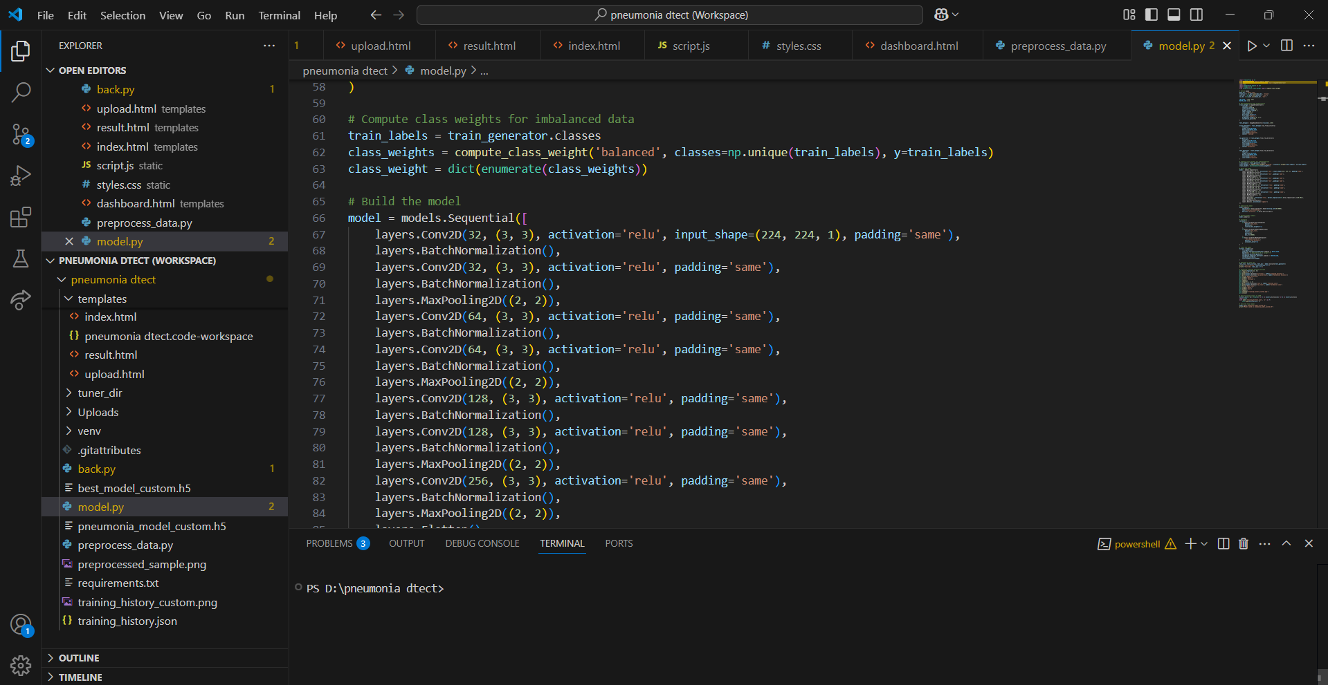

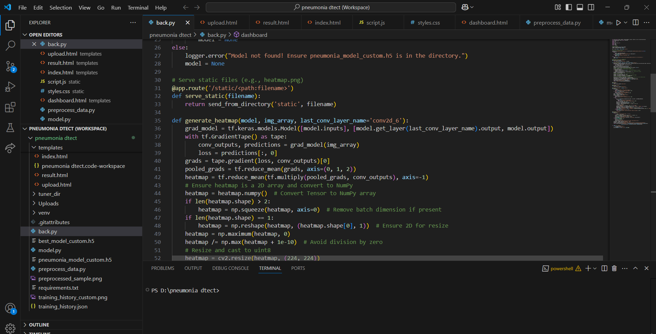

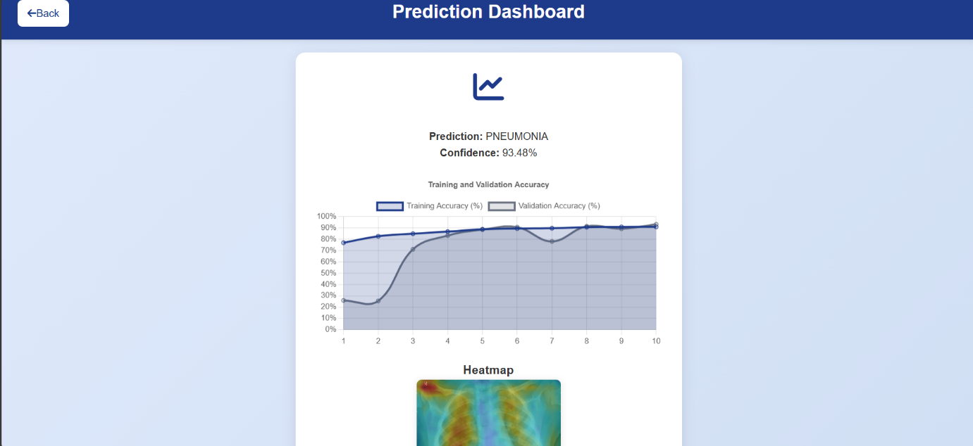

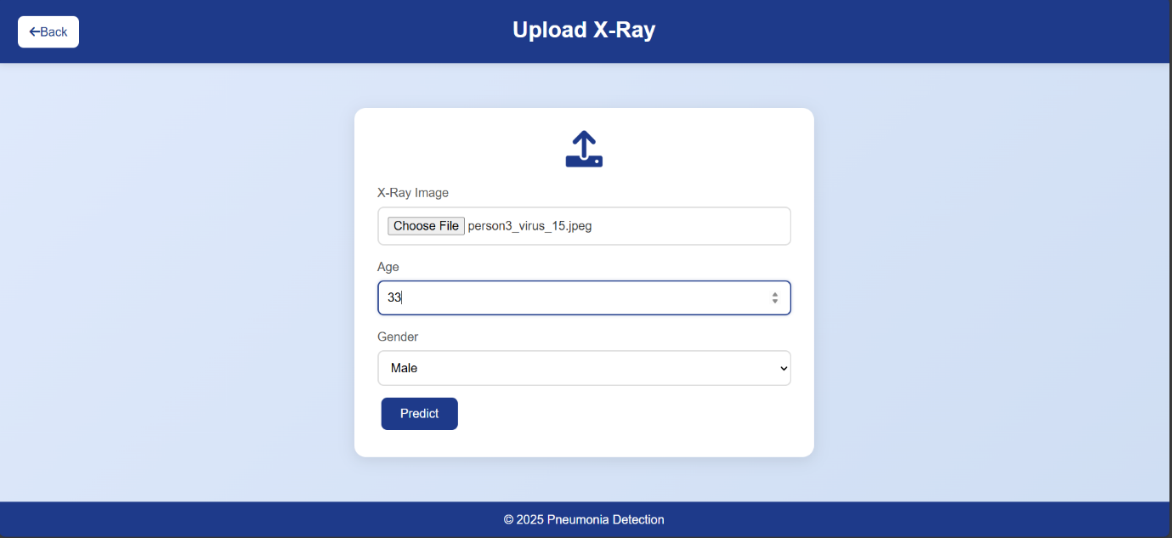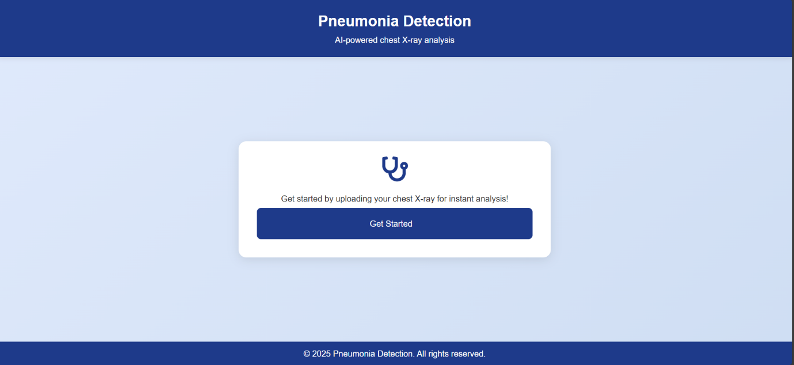

**6. References**

Kaggle Chest X-Ray Images (Pneumonia) Dataset:

🔗 <https://www.kaggle.com/paultimothymooney/chest-xray-pneumonia>